Visualizing and Predicting Heart Diseases with an Interactive Dashboard

# What is a project milestone:

***A Milestone represents a significant point in the development of your project. You can tie Milestones to specific dates, or use them to signify the completion of a portion of the entire project. Milestones can contain other Milestones or Milestone Action Items. You cannot associate a Milestone with other objects in the object hierarchy.***

***A Milestone Action Item is a specific objective that must be completed to reach a Milestone. In general, all Milestone Action Items that are associated with a Milestone must be completed to reach a Milestone. When you are assigned a Milestone Action Item object, it is displayed (if configured) in the My Milestone Action Items section of your My Work tab.***

# What is the difference between tasks and milestone:

***Milestone***

***So, what is a project milestone? It is a management tool for identifying a certain point in a project's timeline. The project milestone may be used to indicate the beginning and end of a project and the conclusion of a significant phase of work. Milestones may be used to represent anything that has begun or been completed (its duration), although they are most often used as a scheduling tool. You can see how a milestone and task may be helpful in scheduling if it focuses on key progress milestones in a project.***

***Milestones assist project managers plan, organize, create and execute project stages in the same way that tasks break down a bigger project into manageable pieces. When you've finished everything relevant to that project phase, is the straightforward answer.***

***Completing the project charter, for example, is typically the final step in the project's start phase. This is the point at which you will set or create your milestone to show that you've progressed from commencement to planning.***

***However, depending on your project, your organization, and other variables, the precise moment you wish to create or add your milestones may differ. It's always advisable to seek advice from industry specialists and members of your business or project team. A little advice now will save you a lot of hassle.***

***Task***

***A project task is a smaller, more manageable component of a larger project. Tasks are like a staircase to the finish line; each step ahead brings you closer to your objectives. The effective execution of each job along the trip is required for a project's successful completion. The following sections describe different project management methods that may assist you in breaking down your project and effectively managing your tasks.***

***A project team typically has several activities planned. Each job will be given to a particular member of the group, and that individual will be in charge of performing the work within a certain amount of time Writing an article (like this one) or setting up a meeting are examples of tasks. For more efficient outcomes, complex, time-consuming activities may be split into smaller subtasks.***

# What is a mile stone schedule:

A milestone schedule or milestone chart is a timeline that uses milestones to divide project work into phases for easy monitoring.

A milestone schedule has the following characteristics: The schedule should be easy to understand

The schedule must be detailed enough to provide the basis for measuring and controlling

The schedule should highlight the critical tasks

The schedule should be flexible enough to modify easily The schedule should depict the realistic timelines

***How to Create a Milestone Schedule:***

The following steps are required in sequence to develop a milestone schedule: Define the Project Objectives

Create Milestones Reviewing the Milestones

1. ***Define Project Objectives:***

The project manager’s first scheduling responsibility is to define [project](https://pmstudycircle.com/project-objectives/) [objectives](https://pmstudycircle.com/project-objectives/) by putting them into quantitative terms. A project objective is a statement that specifies the expected outcomes. They will be examined throughout the project life cycle to see if they fall within the project’s scope. A well-defined project objective should be:

Attainable: The objective should be achievable. Definitive: The objective should be clearly defined.

Quantifiable: Measurable objectives are mandatory to compare performance to a standard.

Specific Duration: The time within which the task is to be achieved is to be defined.

1. ***Create Milestones:***

You must logically categorize the work to generate milestones once the project objectives have been defined. A full work breakdown structure will not be created at this time; instead, a high-level milestone schedule will be created to give a high- level notion of what will be done and in what order.

1. ***Review the Milestones:***

The project manager should ensure that the milestones are realistic once they have been defined. At a high level, the plan should take into account elements such as technical and management reviews, vacations, conflicts, and resource limits that influence the scheduling and budgeting process. The project manager must make sure that the milestones are sensibly ordered and organized.

Because planning is an iterative process, the timetable should be flexible enough to accommodate any project delays.

# Milestone Schedule Example:

Each deliverable at the milestone is assessed with different colour codes as RGA (Red/Green/Amber):

Green indicates that the team has fully met the criteria for the deliverable

Amber/Yellow indicates that the criteria have not been fully met, but the team has a work plan to achieve the criteria

Red indicates that the team has not fully met the criteria and has no plan to meet the criteria (requiring help from management)

Below is an example of a milestone schedule

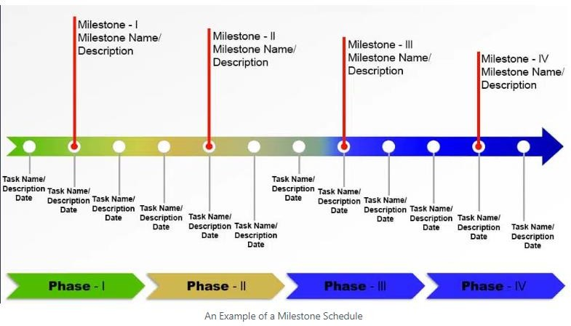

The milestone is approved if the metrics are green for all deliverables. Often, approval is given, even though there are unresolved issues. The program team is responsible for resolving the open issues later.

There can be a milestone review meeting with key [project stakeholders](https://pmstudycircle.com/stakeholders-in-project-management-definition-and-types/). The following questions need to be validated during the meeting:

Were the checkpoints completed, i.e., those events that were due to be finished during the last reporting period?

If yes, were the appropriate deliverables produced out of each of these? If yes, did these deliverables meet the expected quality criteria?

If yes, is work being accomplished with the quality committed? If the answers are yes, then the milestone is achieved.